DEPARTMENT: FED
SUBJECT: DSA-2 (25SC1305E)
ACADEMIC YEAR: I-III Semester (2025-26)
COURSE OUTCOME: CO1
NAME: P. PRANAW REDDY
ROLL NO: 2520030136

Case Study Title
Efficient Student Record Management System Using AVL Tree
Case Study Scenario
A university maintains thousands of student records. Each student is identified by a unique Student ID. The administration frequently performs operations such as:
- Adding new student records
- Searching student details
- Updating records
- Deleting graduated students
If a normal BST is used and records are inserted in sorted order, the tree may become skewed, leading to O(n) search time.
To overcome this issue, the university decides to implement an AVL Tree, which automatically balances itself after every insertion and deletion using rotations.
- Analyze the challenges faced by the university when using a traditional Binary Search Tree (BST) for storing student records. Explain how sequential insertion of student IDs can lead to an unbalanced tree and affect system performance. Illustrate your explanation with a suitable example and tree diagram.
- Design and implement a Java program using AVL Trees to manage student records. The program should support insertion of student IDs and automatically perform balancing operations whenever required.
- Compare the performance of BST and AVL Tree for a university database containing 50,000 student records. Analyze the time complexity of insertion, deletion, and search operation

Ans)
a)Using a standard BST may create an unbalanced tree:

Example insertion order:

10, 20, 30, 40, 50

10
\
20
\
30
\
40
\
50
AVL Tree Solution
AVL Tree maintains:
| Height(Left Subtree) - Height(Right Subtree) | ≤ 1
Whenever imbalance occurs, rotations are performed.
1. Left Rotation (RR Case)
Before Rotation:
10
\
20
\
30
After Rotation:
20
/ \
10 30
2. Right Rotation (LL Case)
Before Rotation:
30
/
20
/
10
After Rotation:
20
/ \
10 30
3. Left-Right Rotation (LR Case)
4. Right-Left Rotation (RL Case)
These rotations ensure that search, insertion, and deletion remain efficient.

b) Java Code

class Node {
int key, height;
Node left, right;

Node(int d) {
key = d;
height = 1;
}
}

public class AVLTree {

Node root;

int height(Node N) {
if (N == null)
return 0;
return N.height;
}

int getBalance(Node N) {
if (N == null)
return 0;
return height(N.left) - height(N.right);
}

Node rightRotate(Node y) {
Node x = y.left;
Node T2 = x.right;

x.right = y;
y.left = T2;

y.height = Math.max(height(y.left),
height(y.right)) + 1;
x.height = Math.max(height(x.left),
height(x.right)) + 1;

return x;
}

Node leftRotate(Node x) {
Node y = x.right;
Node T2 = y.left;

y.left = x;
x.right = T2;

x.height = Math.max(height(x.left),
height(x.right)) + 1;
y.height = Math.max(height(y.left),
height(y.right)) + 1;

return y;
}

Node insert(Node node, int key) {

if (node == null)
return new Node(key);

if (key < node.key)
node.left = insert(node.left, key);

else if (key > node.key)
node.right = insert(node.right, key);

else
return node;

node.height = 1 + Math.max(height(node.left),
height(node.right));

int balance = getBalance(node);

// LL
if (balance > 1 && key < node.left.key)
return rightRotate(node);

// RR
if (balance < -1 && key > node.right.key)
return leftRotate(node);

// LR
if (balance > 1 && key > node.left.key) {
node.left = leftRotate(node.left);
return rightRotate(node);
}

// RL
if (balance < -1 && key < node.right.key) {
node.right = rightRotate(node.right);
return leftRotate(node);
}

return node;
}

void preorder(Node node) {
if (node != null) {
System.out.print(node.key + " ");
preorder(node.left);
preorder(node.right);
}
}

public static void main(String[] args) {

AVLTree tree = new AVLTree();

tree.root = tree.insert(tree.root, 10);
tree.root = tree.insert(tree.root, 20);
tree.root = tree.insert(tree.root, 30);
tree.root = tree.insert(tree.root, 40);
tree.root = tree.insert(tree.root, 50);

System.out.println("Preorder Traversal:");
tree.preorder(tree.root);
}
}
Output:-
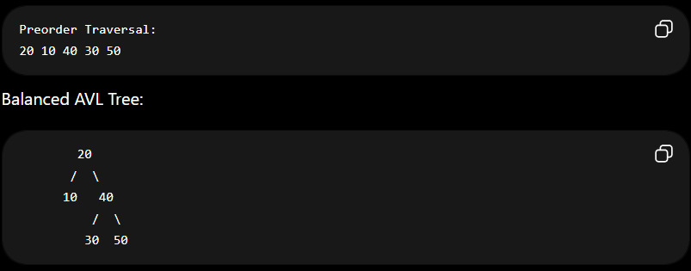

c) Compare Time Complexities of BST and AVL Tree
Operation | BST (Worst Case) |  |  | AVL Tree
Search | O(n) |  |  | O(log n)
Insert | O(n) |  |  | O(log n)
Delete | O(n) |  |  | O(log n)
Traversal | O(n) |  |  | O(n)
Height | O(n) |  |  | O(log n)

Conclusion:-
The AVL Tree-based Student Record Management System provides efficient insertion, deletion, and search operations even for very large datasets. Unlike a standard BST, AVL Trees maintain balance through rotations, guaranteeing O(log n) performance and making them ideal for university database management systems.

Github link: https://github.com/pranawreddy36-byte/DSA-casestudy.git

